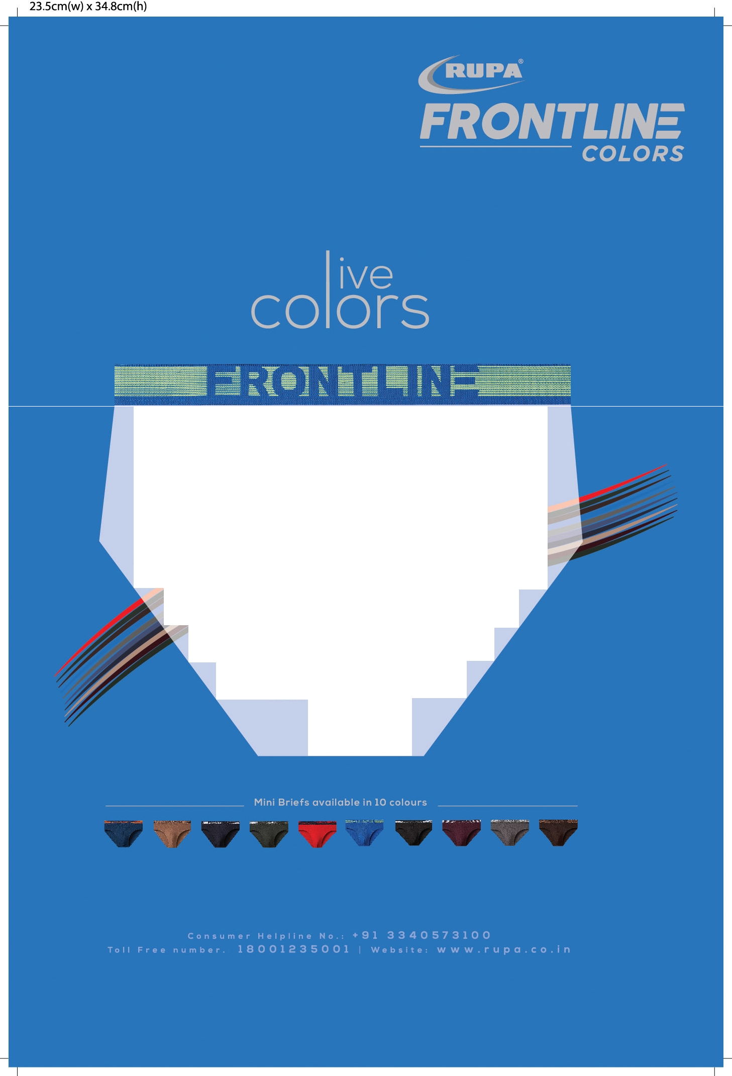

Rupa FrontUne Colors has a surprise gift for you this New Year 2022.
Be prepared to unwrap your gift and find:

A three dimensional representationof a colour model
  - An analog of the two-dimensionalcolour wheel
• A toolto organize hue,lightness and saturation to compose avisualart.
If youareslightly amused and confused after reading this,you haveevery reason to.
May we request you to be patient and read on.
Allof these are properties of the SOLID COLOR and Rupa Frontline Colors presents youwith exactly this.A choice of ten,enviable, Solid Colors to grace your new year wardrobe.
By the way, these solids are not for the faint-hearted.For those of you wholove to flaunt that chise ed body of yours in a daring Mini Brief,
this gift is perfect for you.
Rupa Frontline Mini Briefs come inspicy Red,moody Wine,sprightly Mouse, chocolatey Brown,fresh Olive Green,the three enviable blues - Airforce,Navy and Royaland of course the very
British Charcoalas wellas the elegant Black.
Dare to f aunt your MiniBriefs!!

Live your Life. Live Colors.

