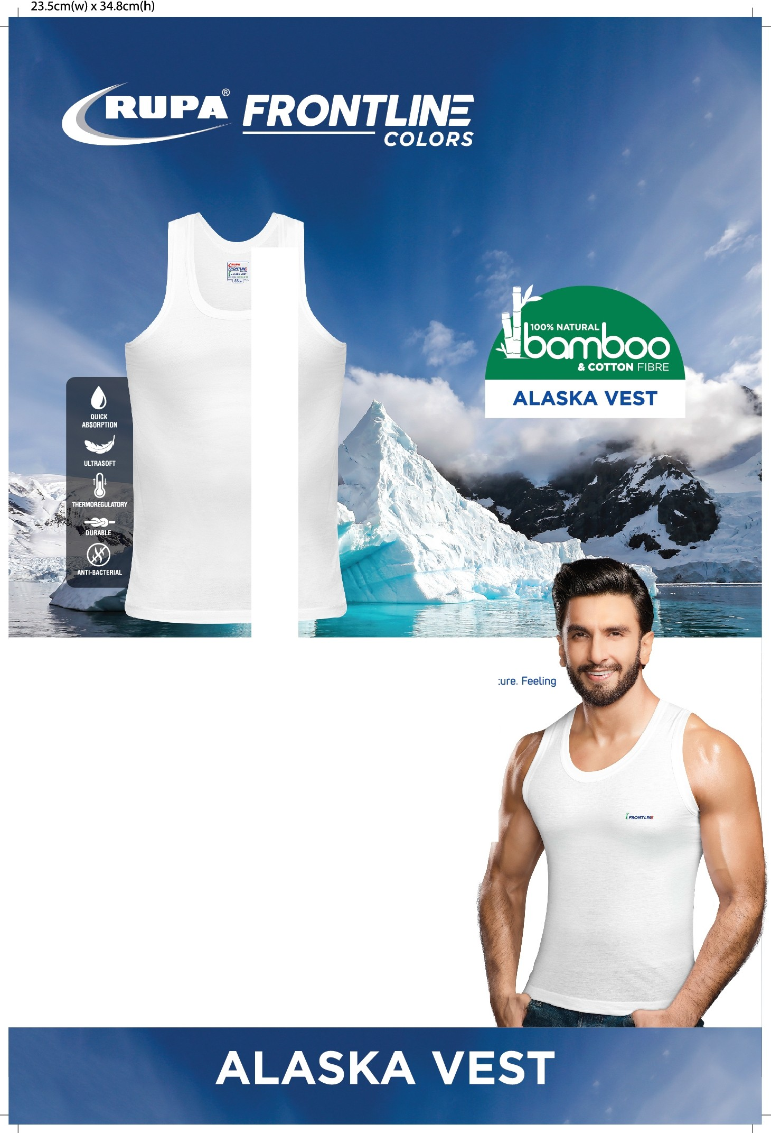

JrawntH:

Rupa Frontline Colors presents an extraordinary,100% natura gift cal ed'Alaska Vest'.
Why is Alaska vest an extraordinary gift? Because the vest is a double-decker gift from nature.
Feeling curious? Wish to know more?

Here'sthe story.
The Alaska vest in white colour is made of 50% Bamboo and 50% Cotton fibres. Bamboo fibres are unique as they contain anti-bacterial and anti-fungal bio agents with micro-gaps which pullmoisture away from the body, making Bamboo an odour-resistant,moisture-wicking fabric. What's more,since Bamboo isalkali sensitive,it is super-soft, ustrous, and gives you
a feeling of second skin when combined with cotton.

Now that we know what the Alaska Vest is made of, let's see how it looks.

The shape of the vest is modern and designed especial y for today's youth.Check out the high coverage onthe back of the neck, the broadshoulder straps,and the sporty cutwhich the Alaska vest offers. Gladly for us, the vest retains its shape despite repeated washes.
You must be wondering how allthis is possible. Let us tellyou the secret.
We have a mix in the yarn which has been used for stitching.The result is the added durability you get despite stretched movements. repeated washes, and allthe other pulls and tugs that the Alaska vest goes through in a day, while clingingonto your body.
Pristine white in Colour, sporty and trendy in Look, soft and ustrous in Fee top of the charts in Hygiene with zero moisture and free of odour.
We have ticked al the boxes.This is our best in-Vest-ment inspired from nature. The Alaska vest from Rupa Frontline Colors welcomes allits customers.

Wear itto feel it.

