~Bumchums amplifies the Fun quotient with its new campaign~
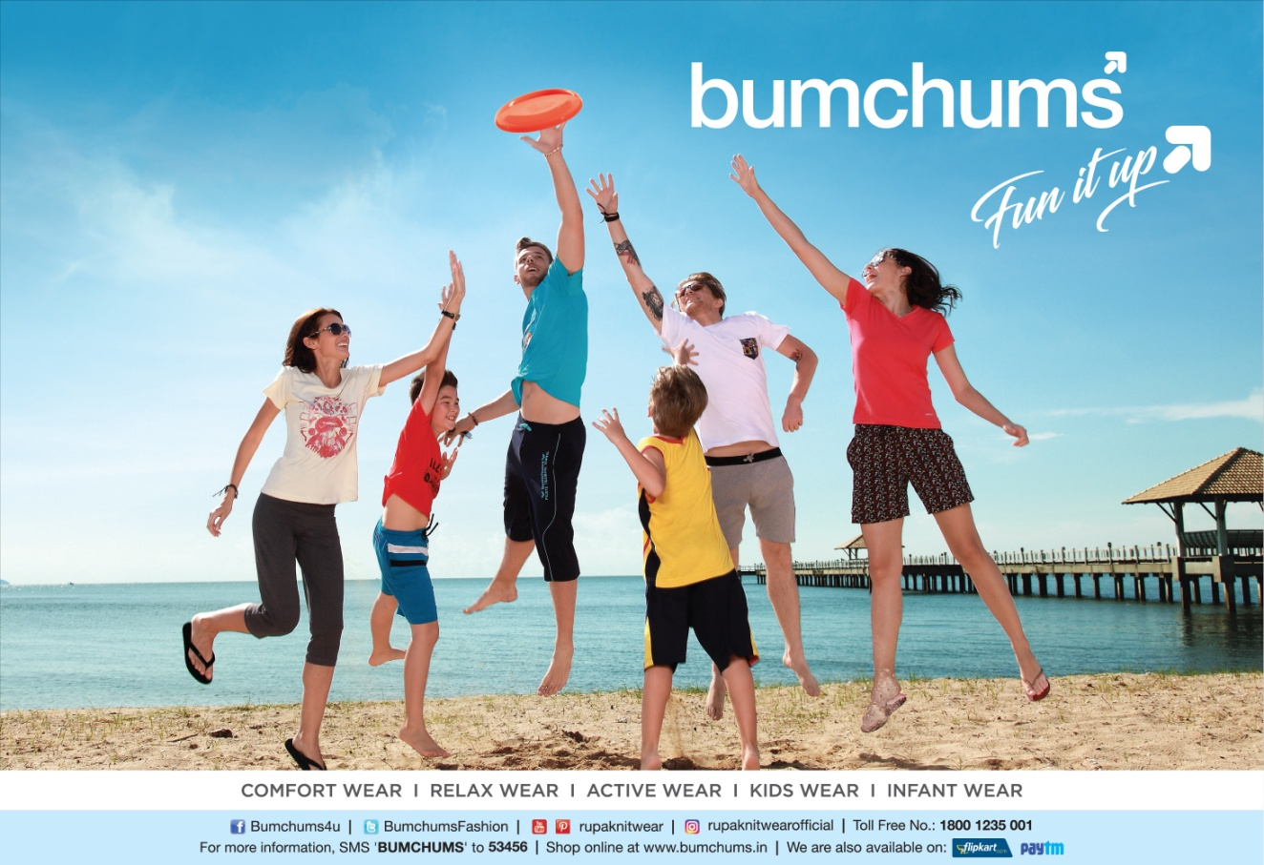
Kolkata, 9th March, 2017: Bumchums launches new ad campaign to reinforce its core message, Fun It Up! The new campaign is an attempt by the brand to resuscitate its public perception, and emerge as a young and fashion forward brand that it is!
Announcing the launch, Mr Rajnish Agarwal, Brand President, Bumchums said, "We are delighted to roll out the new campaign. With this, we plan to give a fresh look to the brand and add up to the fun quotient. To harp on this, we’ve amplified our tagline “Fun It Up”. Now you’ll see our tagline in a much bigger font positioned in a slanting way. The slant in the tagline signifies a deviation from the mundane and boring, and clearly points towards the newer and happening things in life.
We’ve also added an arrow to the tagline, which again highlights our fashion forwardness and strengthens our commitment to bring the best to our consumers.”
The new campaign has been conceptualized by Scarecrow Communications Ltd. and is shot in an exotic location abroad.
“The new Bumchums campaign is all about fun and frolicking. We’ve used bright, effervescent colours to give the campaign a youthful feel that was much desired. The choice of venue is much in sync with the brand proposition and the target group it caters to”, confirms Mr Arunava Sengupta, Founder Director, Scarecrow Communications Ltd.
Bumchums’ new campaign focuses on enhancing the brand perception, as well as to establish a stronger connect with the end consumers. The brand also aims to highlight its product offerings and its wide product portfolio through the campaign.
Bumchums has modelled a 360 degree marketing plan to launch the campaign. Hitting it off with the print media, the campaign also integrates outdoor and digital spaces for promotion.

About Bumchums:
Bumchums is a casual wear brand owned by Rupa & Co. Ltd., which provides cool casuals and trendy Tshirts, Bermudas, Loungers and Capris for young men, women and kids. The brand also offers dedicated products like baba suits and frocks for toddlers.
Bumchums Online: www.bumchums.in
Bumchums Social: Bumchums4u; @BumchumsFashion

About Rupa and Company Limited:
Rupa and Company Limited is one the largest knitwear brands in India engaged in the manufacturing, branding and marketing of innerwear and casual wear for men and women. The Company was established in 1968 as Binod Hosiery, and today it is one of the leading players in Indian Knitwear Industry and holds the ‘Limca Book of Records’ for being the largest inner wear & casual wear manufacturing company in India for 11 consecutive years.
Among the prominent awards won by the Company are Worldwide Achievers Business Leadership Award (2013-14), Time Research Business Leadership Awards for Branch Excellence in Innerwear (2013), and Global awards for Brand Excellence by World Brand Congress during the year 2010. Recently, the Company has been selected as the Best Corporate Brand 2016 by The Economic Times of India.
Rupa Corporate: www.rupa.co.in

Contact info:
Rimmy Sett Banerjee
Rupa & Company Limited
1, Ho Chi Minh Sarani, Metro Tower, Kolkata - 700071
Tel: +91 33 3057 3100 / 3186 | Email: srexe.dpc@rupa.co.in

